46
PHARRS ISLAND

HABITAT REHABILITATION AND ENHANCEMENT PROJECT

Pool 24
Upper Mississippi River Miles 275.5-277.3

Pike County, Missouri
St. Louis District

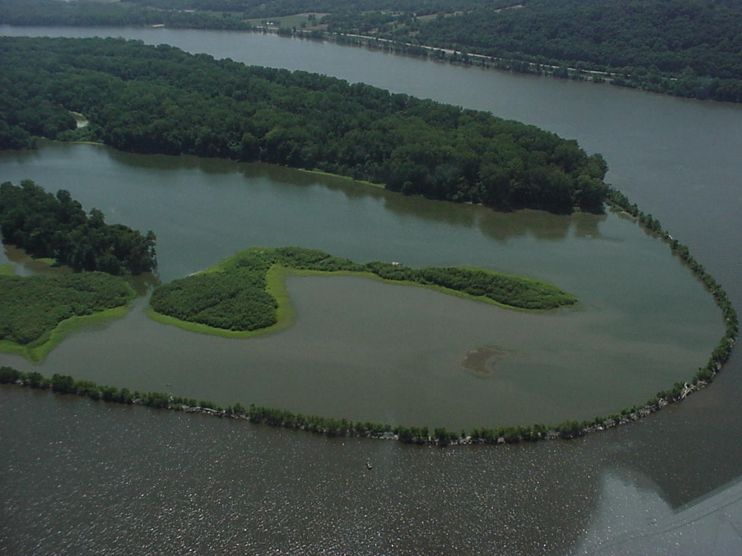

RESOURCE PROBLEM:

The area is managed for fish and wildlife purposes under a cooperative agreement with the Missouri Department of Conservation. Due to years of siltation, both the quality and quantity of backwater/wetland habitat have deteriorated in the project area.
PROJECT FEATURES:

- Construct a 10,200 –foot long upstream emergent rock dike to deflect sediment from the wetlands complex and to provide additional off-channel water habitat (Phase I);

- Install 9 large fish attractors in Pharrs Island interior backwater (Phase I); and

- Construct a levee system to reduce sediment input into the lower island complex (Phase II).

PROJECT OUTPUTS:

The project eliminated most sediment from entering the island complex during frequent lower elevation flood events. The sediment reduction has greatly extended the utility of the complex as fish and wildlife habitat. The deep, sediment-protected, off-channel water area created by the project has provided an important spawning, rearing, and wintering habitat for riverine fish populations. The project also provides some ingress and egress of fish to the Pharrs Island interior wetlands during the spawning period.

FINANCIAL DATA:

General design costs were $233,000, and construction costs were $1,115,000. Annual costs for operation, maintenance, and repair are estimated at $5,500 and are the responsibility of the non-Federal project sponsor, the Missouri Department of Conservation.

STATUS:

The project was approved for construction in June 1991. Phase I Construction was completed in June 1992. Phase II construction has been deferred.

